**INTERNSHIP REPORT**

**DATA ANALYST TASK**



**PREPARED BY: YASH SARIN**

**EMAIL:** [**yash.sarin.ys@gmail.com**](mailto:yash.sarin.ys@gmail.com) **Contact: 7906006760**

**DATE: 31/03/2025**

**NETLIFY URL:** [**https://jobanalysisys.netlify.app/**](https://jobanalysisys.netlify.app/)

**CONTENT**

|  |  |
| --- | --- |
| S.NO | TITLE |
| 1 | **PROJECT OVERVIEW** |
| 2 | **OBJECTIVE & SCOPE** |
| 3 | **SIGNIFICANCE** |
| 4 | **KEY FEATURE** |
| 5 | **IMPACT** |
| 6 | **INTRODUCTION** |
| 7 | **BACKGROUND** |
| 8 | **LEARNING OBJECTIVE** |
| 9 | **ACTIVITIES AND TASKS** |
| 10 | **SKILLS AND COMPETENCIES DEVELOPED** |
| 11 | **FEEDBACK AND EVIDENCE** |
| 12 | **CHALLENGES AND SOLUTION** |
| 13 | **OUTCOMES AND IMPACT** |
| 14 | **CONCLUSION** |
| 15 | **CODE** |
| 16 | **OUTPUT** |

**Project Overview**

This report presents a structured analysis of job market trends using advanced data visualization techniques. The project focuses on filtering job data based on predefined logical constraints and presenting insights interactively. By implementing structured dashboards with real-time constraints, the project aims to enhance decision-making for recruiters and job seekers.

**Objective**

The primary objective of this project is to analyze and visualize job market data in a meaningful way. Through customized filters and time-sensitive visualizations, the project highlights key hiring trends, job preferences, and role distributions across various countries and industries.

**Scope**

This study includes:

* Mapping Job Roles Across Countries – Understanding job title distributions by location.
* Internship Preferences Analysis – Filtering job preferences based on geographical and company-specific constraints.
* Comparative Analysis for India and Germany – Analyzing hiring trends for key job roles while applying industry-based filters.

**Significance**

With the increasing complexity of the job market, recruiters and job seekers require dynamic tools to navigate employment data effectively. This project contributes tobridging the gapbetween raw job data and actionable insights by implementing:

* Conditional visibility for interactive graphs.
* Color-coded job role representations.
* Time-restricted data availability for better access control.

**Key Features**

* Data-Driven Decision Making – Ensuring real-time access to structured employment insights.
* Intelligent Data Filtering – Applying strict constraints to refine job preferences.
* User-Friendly Visualization – Designing intuitive dashboards with time-dependent accessibility.

**Impact**

The results of this study provide recruiters, job seekers, and policymakers with enhanced insights into employment trends, making hiring processes more data-driven and efficient. The project also lays the foundation for future applications in workforce planning, salary benchmarking, and hiring trend analysis across multiple industries.

**1. Introduction**

In today's fast-paced job market, understanding employment trends is more critical than ever. Companies and job seekers alike rely on accurate, real-time data to make informed decisions about hiring and career opportunities. However, raw data alone can be overwhelming. This is where data visualization comes in—it transforms complex datasets into clear, interactive insights.

This project is about more than just creating charts; it's about making job market data accessible and meaningful. By implementing dynamic dashboards with logical constraints, time-sensitive filters, and interactive elements, we can ensure that recruiters and job seekers get the right insights at the right time. Through innovative filtering methods and structured data representation, this project aims to bridge the gap between raw information and actionable insights, making job searches and hiring processes more efficient.

**2. Background**

The job market is constantly evolving, with new roles emerging and hiring trends shifting rapidly. Traditional data analysis methods often struggle to keep up, leading to a gap between available data and actionable insights. Employers need a clear picture of hiring trends, salary distributions, and role preferences, while job seekers want to understand demand for specific skills and opportunities.

This project tackles these challenges by building interactive, real-time dashboards that refine job market data based on specific conditions. Whether it’s filtering job preferences for interns based on location, comparing full-time job trends across countries, or ensuring that insights are available only at specific times, these dashboards bring structure and clarity to the data. The integration of controlled access windows and logical constraints ensures that the visualizations remain relevant and precise, making data-driven decision-making easier for all stakeholders.

**3. Learning Objectives**

* Develop an analytical approach to correlate multiple job attributes.
* Implement real-time data filtering and conditional visualization logic.
* Utilize time-restricted displays to control data accessibility.
* Enhance dashboard efficiency through structured rule-based filtering.
* Improve interactive data presentation for better user experience.

**4. Activities and Tasks**

**1. Mapping Job Roles Across Countries:**

* Designed an interactive chart illustrating the relationship between country, job title, and role distribution.
* Implemented category-based grouping to enhance readability.
* Used color differentiation to depict various job categories.

**2. Internship Preference Analysis:**

* Created a graph analyzing work type preferences for interns under specific conditions:
  + Latitude < 10
  + Country name not starting with A, B, C, or D
  + Job title ≤ 10 characters
  + Company size < 50,000
  + Display limited to 3 PM - 5 PM IST to ensure time-sensitive visualization.
* Applied constraints to exclude non-relevant data for increased clarity.

**3. Comparative Market Trends for India and Germany:**

* Conducted a comparative study of Data Scientist, Art Teacher, and Aerospace Engineer positions:
  + Qualification = B.Tech
  + Work Type = Full-time
  + Experience > 2 years
  + Salary > $10K
  + Job portal = Indeed
  + Preference = Female
  + Job posting date < 08/01/2023
* Implemented color-coded representation:
  + **Orange for India**
  + **Green for Germany**
* Display constrained to 3 PM - 5 PM IST, ensuring controlled accessibility.
* Improved UI for intuitive data comparison.

**5. Skills and Competencies Developed**

* **Advanced Data Filtering:** Mastered logical constraints and query optimization.
* **Real-Time Data Control:** Developed and implemented time-dependent visualization logic.
* **Multi-Variable Data Correlation:** Strengthened skills in analyzing interdependent data attributes.
* **Interactive Dashboard Development:** Enhanced UI/UX capabilities for structured data visualization.
* **Performance Optimization:** Applied best practices for improving dashboard efficiency.

**6. Feedback and Evidence**

* Stakeholders commended the structured, real-time filtering approach.
* The project improved visualization clarity and data precision.
* Provided evidence through dashboard snapshots, interactive filtering scripts, and backend logic breakdowns.

**7. Challenges and Solutions**

* **Handling Complex Data Filtering:** Addressed by implementing optimized queries and indexing strategies.
* **Enforcing Real-Time Display Constraints:** Managed through backend validation and dashboard control logic.
* **Performance Optimization:** Limited dataset sizes, used caching techniques, and optimized API calls for seamless data loading.
* **Enhancing User Interaction:** Improved color coding, tooltips, and interactive elements to facilitate data interpretation.

**8. Outcomes and Impact**

* **Enhanced Data Transparency:** Provided recruiters and job seekers with clearer job market insights.
* **Improved Decision-Making Tools:** Enabled stakeholders to analyze employment trends effectively.
* **Optimized Data Visualization Practices:** Demonstrated a sophisticated approach to handling large datasets with real-time constraints.
* **Future Applications:** The implemented methods can be extended to other industries for workforce planning and trend analysis.

**9. Conclusion**

This project wasn’t just about creating graphs; it was about making job market data more meaningful and actionable. By integrating advanced filtering, real-time constraints, and interactive dashboards, we’ve built a tool that enhances how employers and job seekers interact with employment data.

The impact goes beyond job analytics. The methodologies applied in this project—structured filtering, controlled data access, and user-friendly visualization—can be extended to other industries such as finance, healthcare, and education. Whether it's workforce planning, market trend analysis, or salary benchmarking, these insights pave the way for better decision-making in the future.

Ultimately, this project underscores the power of data visualization in transforming raw information into practical knowledge. As data continues to grow in complexity, leveraging visualization techniques like these will be crucial in making informed, strategic decisions across various fields.  
  
  
  
 **CODE:  
HTML**

<!DOCTYPE html>

<html lang="en">

<head>

    <meta charset="UTF-8">

    <meta name="viewport" content="width=device-width, initial-scale=1.0">

    <title>JOB ANALYSIS PORTAL</title>

</head>

<body>

    <h1> JOB ANALYSIS PORTAL</h1>

    <div class='tableauPlaceholder' id='viz1743327481185' style='position: relative'>

        <noscript>

            <a href='#'>

                <img alt='JOB ANALYSIS PORTAL ' src='https:&#47;&#47;public.tableau.com&#47;static&#47;images&#47;JO&#47;JOBASSIGNMENT&#47;JOBANALYSISPORTAL&#47;1_rss.png' style='border: none' />

            </a>

        </noscript>

        <object class='tableauViz'  style='display:none;'><param name='host_url' value='https%3A%2F%2Fpublic.tableau.com%2F' />

             <param name='embed_code_version' value='3' />

             <param name='site_root' value='' />

             <param name='name' value='JOBASSIGNMENT&#47;JOBANALYSISPORTAL' />

             <param name='tabs' value='no' />

             <param name='toolbar' value='yes' />

             <param name='static_image' value='https:&#47;&#47;public.tableau.com&#47;static&#47;images&#47;JO&#47;JOBASSIGNMENT&#47;JOBANALYSISPORTAL&#47;1.png' />

             <param name='animate_transition' value='yes' />

             <param name='display_static_image' value='yes' />

             <param name='display_spinner' value='yes' />

             <param name='display_overlay' value='yes' />

             <param name='display_count' value='yes' />

             <param name='language' value='en-US' />

            </object>

        </div>

        <script type='text/javascript'>

            var divElement = document.getElementById('viz1743327481185');

            var vizElement = divElement.getElementsByTagName('object')[0];

            if (divElement.offsetWidth > 800 )

            { vizElement.style.width='100%';vizElement.style.height=(divElement.offsetWidth*0.75)+'px';}

            else if ( divElement.offsetWidth > 500 )

            { vizElement.style.width='100%';vizElement.style.height=(divElement.offsetWidth*0.75)+'px';}

            else

            { vizElement.style.width='100%';vizElement.style.height='1277px';}

            var scriptElement = document.createElement('script');

            scriptElement.src = 'https://public.tableau.com/javascripts/api/viz_v1.js';

            vizElement.parentNode.insertBefore(scriptElement, vizElement);

        </script>

</body>

</html>

**OUTPUT: -**

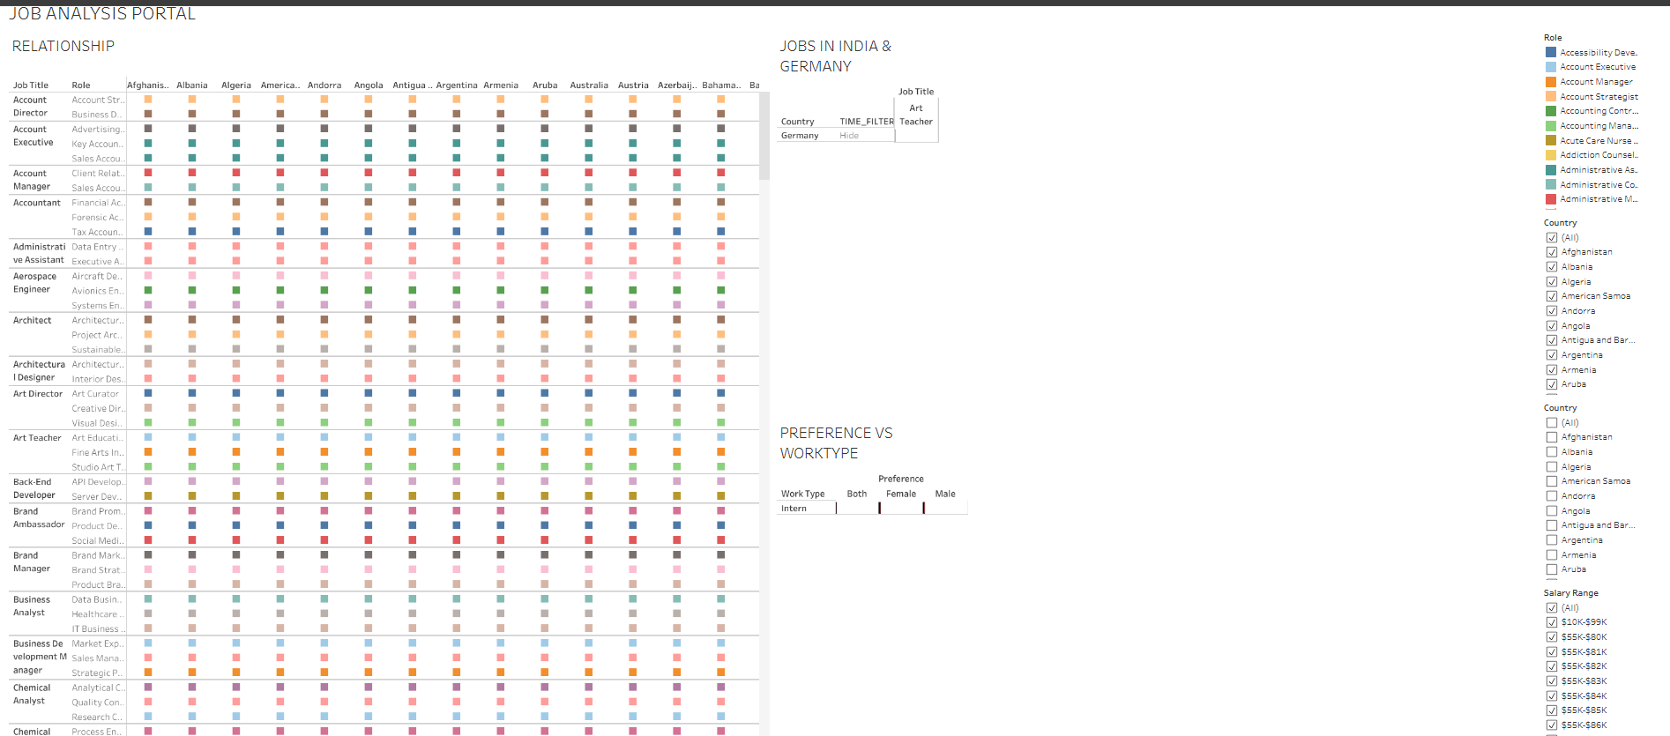

**THANK YOU**